Maintenance Dashboard for Equipment Monitoring using Excel and Power BI

R. Nikhil Yadav
Apex Institute of Technology Chandigarh University (UGC, AICTE approved) Mohali, Punjab 22BAI71307@cuchd.in

M. Ramakrishna Reddy
Apex Institute of Technology Chandigarh University (UGC, AICTE approved) Mohali, Punjab 22BAI71314@cuchd.in
Mukesh Kumar Varma Apex Institute of Technology Chandigarh University (UGC, AICTE approved) Mohali, Punjab e18211@cuchd.in

S. Sasi Pranav
Apex Institute of Technology Chandigarh University (UGC, AICTE approved) Mohali, Punjab 22BAI70625@cuchd.in

Anand Kumar
Apex Institute of Technology Chandigarh University (UGC, AICTE approved) Mohali, Punjab 22BAI71306@cuchd.in

Abstract—A key factor in guaranteeing the dependability and accessibility of industrial assets is maintenance management. Conventional techniques for tracking maintenance events, repair expenses, and downtime frequently fall short of offering timely information for decision-making. The design and implementation of a thorough maintenance dashboard in Excel and Power BI is presented in this paper, with an emphasis on key performance indicators (KPIs) like Mean Time to Repair (MTTR), Mean Time Between Failures (MTBF), downtime duration, and cost trends. Stakeholders can examine scheduled and unscheduled maintenance, repair costs by technician, and asset downtime distribution by simulating and visualising three months’ worth of maintenance data on the dashboard. With the help of predic- tive maintenance techniques and Total Productive Maintenance (TPM) principles, the dashboard improves operational perfor- mance visibility and facilitates data-driven decision-making. The findings show that visual reporting and predictive analytics enhance maintenance scheduling, lower operating expenses, and boost equipment availability. The suggested system demonstrates how business intelligence (BI) tools can be used to continuously enhance industrial maintenance procedures.
Index Terms—MTTR, MTBF, power BI, predictive mainte- nance, total productive maintenance (TPM), maintenance dash- board, business intelligence (BI), equipment downtime, mainte- nance analytics

  - Introduction
- Background
Industrial performance and sustainability are significantly impacted by maintenance. Businesses make significant in- vestments to guarantee that machinery is dependable, secure, and able to support ongoing production cycles. Unplanned downtime can cost manufacturing industries $260,000 per hour on average, according to studies [1]. Industries use struc- tured maintenance procedures, backed by key performance indicators (KPIs) like equipment availability, Mean Time to Repair (MTTR), and Mean Time Between Failures (MTBF), to reduce such risks. However, the real-time and predictive
capabilities required for contemporary decision-making are frequently absent from traditional spreadsheet-based tracking [2].
- Total Productive Maintenance (TPM)
In 1988, Nakajima introduced Total Productive Mainte- nance (TPM), a comprehensive maintenance approach that emphasises employee involvement and preventive measures to maximise equipment effectiveness [2]. A systematic method for reaching zero breakdowns and zero defects is established by the eight TPM pillars: office TPM, training, safety, focused improvement, autonomous maintenance, planned maintenance, quality maintenance, and early equipment management [7]. Industries use Overall Equipment Effectiveness (OEE), a metric based on performance rates, quality, and downtime analysis, to gauge the efficacy of TPM. A culture of continuous improvement can be facilitated by a dashboard that incorpo- rates TPM principles and offers insight into scheduled versus unscheduled maintenance, technician workload, and downtime causes [3][5].
- Predictive Maintenance
Predictive maintenance uses data analytics, sensors, and machine learning to foresee equipment failures before they happen, whereas TPM focusses on prevention [3]. Predictive strategies, which are based on condition monitoring, optimise costs by servicing machines only when necessary, in contrast to periodic preventive maintenance. Managers can drastically cut downtime and repair expenses by switching from reactive to proactive decision-making by integrating predictive insights into business intelligence dashboards [4].
- Objectives
Even though BI platforms are becoming more and more popular, industries—small and medium-sized businesses

(SMEs) in particular—find it difficult to implement advanced maintenance solutions because of high implementation costs, dispersed data sources, and little room for customisation [6]. Objectives :-
  - To create a maintenance dashboard that visualises key performance indicators (KPIs) like maintenance costs, downtime, MTTR, and MTBF using Excel and Power BI.
  - To combine predictive maintenance techniques and TPM principles into a single analytical platform [8].
  - To validate dashboard performance, three months’ worth of maintenance data will be simulated and analysed.
  - To offer practical information about trends in repairs, scheduled versus unscheduled maintenance, and cost al- location.
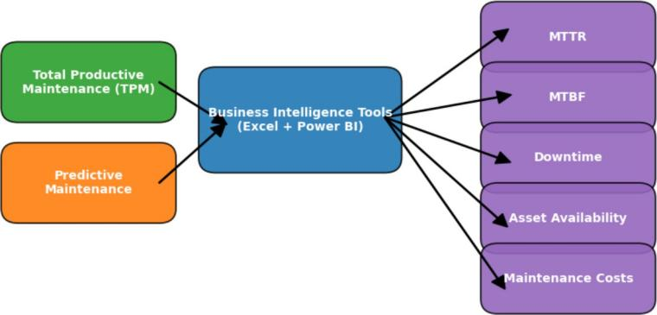

Fig. 1. Integration of TPM, Predictive Maintenance, and BI Tools.

TPM and Predictive Maintenance act as inputs to Business Intelligence platforms (Excel/Power BI), which then generate KPIs such as MTTR, MTBF, Downtime, Asset Availability, and Maintenance Costs.
Problem Statement: There is currently no flexible, afford- able, and user-friendly solution for maintenance monitoring that integrates predictive insights and TPM metrics for in-the- moment decision-making [9].
  - Literature Review
Over the years, maintenance management and analytics have changed from manual record-keeping to data-driven decision- making made possible by business intelligence (BI) tools like Excel and Power BI, Total Productive Maintenance (TPM), and Predictive Maintenance. This section summarises the results of important studies conducted in these fields and points out any gaps that are pertinent to the current work.
- Foundations of Total Productive Maintenance (TPM)
TPM was first identified by early research as a methodical way to increase equipment effectiveness by decreasing mal- functions and increasing operator participation.
  - Equipment reliability was greatly increased by Naka- jima’s (1988) introduction of TPM concepts, which fo- cused on eight pillars like planned maintenance and autonomous maintenance [10].
  - TPM adoption in Indian industries was shown by Ahuja & Khamba (2008) to increase productivity and decrease downtime, despite mentioned difficulties with cultural adaptation [11].
- Preventive and Predictive Maintenance Evolution
The shift from preventive to predictive maintenance brought in data-driven strategies that made use of machine learning and sensor data.
  - Condition-based maintenance (CBM) methods were re- viewed by Jardine et al. (2006), who found that predictive models, as opposed to scheduled preventive strategies, decreased unplanned stoppages [12].
  - In order to improve Mean Time Between Failures (MTBF), Lee et al. (2014) introduced cyber-physical systems for predictive maintenance, with a focus on IoT- driven monitoring [13].
  - Mobley (2002) pointed out that predictive techniques can save costs, but that their implementation calls for a significant financial outlay and highly qualified personnel [14].
- Maintenance Performance Measurement (MTTR, MTBF, OEE)
To assess maintenance efficiency, researchers have concen- trated on defining and standardising KPIs.
  - A maintenance concept framework was created by Waeyenbergh & Pintelon (2002), who emphasised the significance of MTTR and MTBF for benchmarking [15].
  - KPIs were connected to Overall Equipment Effectiveness (OEE) by Muchiri & Pintelon (2008), who examined performance measurement in maintenance [16].
  - According to Eti et al. (2006), KPI-based maintenance planning significantly improved performance in Nigerian industries [17].
- Business Intelligence (BI) in Maintenance Analytics
The use of interactive dashboards in maintenance analytics has increased with the development of BI tools.
  - When talking about BI success factors, Wixom & Watson (2010) emphasised the importance of data quality and effective visualisation [18].
  - A. Ayad (2010) improved the transparency of KPIs by integrating BI tools with manufacturing data to track machine utilisation [19].
  - F.Nunes (2019) demonstrated that by displaying real-time KPIs, BI dashboards improved manufacturing decision- making speed [20].
- Power BI and Excel in Industrial Applications
Excel and Microsoft Power BI have become well-liked tools for operational dashboards.
  - Power BI dashboards enhanced manufacturing energy consumption monitoring, as demonstrated by Singh [21].
  - S.Kong provided low-cost solutions for SMEs by demon- strating the use of Excel-based TPM implementation [22].

  - Small businesses frequently underuse advanced features of BI tools, according to V.V. Iyer, who also highlighted these tools as enablers for operational excellence [23].
- Digital Transformation and Smart Maintenance
Industry 4.0 technologies are being investigated in recent works to improve decision-making and predictive mainte- nance.
  - A framework for proactive decision-making in predictive maintenance that integrates analytics and the Internet of Things was proposed by Bousdekis et al. (2015) [24].
  - Digitalisation is crucial for developing intelligent mainte- nance systems, according to Ylipa¨a¨ et al. (2017), although industrial adoption was uneven [25].
  - Machine learning models were used to forecast failures, but they pointed out that they weren’t integrated with dashboards that were easy to use [26].
- Current Gaps
The gaps found in this review are as follows:
  - Limited BI Integration: A lot of research on predic- tive maintenance is still algorithm-focused and does not incorporate into useful BI dashboards.
  - Dashboard-Centric Research Scarcity: Few studies specifically design dashboards that visualize MTTR, MTBF, downtime, and costs in real time.
  - Accessibility for SMEs: While large enterprises adopt
This stage ensured that the dataset was consistent, reliable, and ready for further analysis [28].
- Data Modeling (Power BI)
The dataset was imported into Power BI for advanced modelling after it had been cleaned. Converting unstructured maintenance data into a relational model that was able to facilitate cross-dimensional analysis was the main goal here.
Important actions involved [29]:
- Table Structuring: Making distinct tables for cost records, maintenance schedules, and equipment informa- tion.
- Relationships: Defining many-to-many and one-to-many relationships (e.g., one piece of equipment → multiple repair events).
- Calculated Measures: KPIs like failure frequency, cu- mulative downtime, and monthly repair costs are dynam- ically calculated using DAX (Data Analysis Expressions).
- Time Intelligence Functions: Integrating date hierar- chies (year, quarter, month) to enable trend analysis across time periods.
- KPI Calculation
Four main Key Performance Indicators (KPIs) were com- puted [30]:

Mean Time to Repair (MTTR):

predictive tools, SMEs need simpler, low-cost BI solu- tions (e.g., Excel + Power BI).
  - Lack of TPM + Predictive Maintenance Synergy: Studies often treat TPM and predictive maintenance sep- arately rather than as complementary strategies.
This project fills these gaps by creating a maintenance management dashboard in Power BI and Excel that visualises
Total Repair Time
MTTR = Number of Repairs

Mean Time Between Failures (MTBF):
Total Operational Time
MTBF = Number of Failures

Downtime:
(1)

(2)

KPIs like asset availability, downtime, MTTR, and MTBF by fusing predictive analytics with TPM principles.
- Methodology
A. Data Preparation (Excel)
Raw maintenance records were first gathered, which in- cluded information on the type of equipment, the date of the event, the repair time, the number of hours of downtime, the labour cost, and the use of spare parts. Excel’s versatility in cleaning and organising structured data led to its selection as the staging platform [27].
The following tasks were part of the data preparation process:
- Data Cleaning: Removal of duplicates, missing values, and formatting inconsistencies (e.g., different date for- mats).
- Standardization: Normalizing fields such as equipment ID, fault codes, and cost categories to ensure uniformity.
- Preliminary KPI Computation: Basic metrics such as Mean Time to Repair (MTTR), Mean Time Between Failures (MTBF), downtime, and maintenance costs were first validated using Excel formulas and pivot tables.
Downtime = Σ(Time Equipment is Non-Operational)
(3)

Maintenance Cost:
Cost = Labor Cost+Spare Parts+Outsourcing Services
(4)
These KPIs were first validated in Excel using formulas and pivot tables before being moved to Power BI.
- Dashboard Development Workflow
The following methodical process was used in the creation of the maintenance dashboard [31]:

Step 1: Data Preparation (Excel)
  - Import raw maintenance data.
  - Clean, filter, and standardize fields.
  - Compute preliminary KPIs (MTTR, MTBF, down- time, costs).

Step 2: Data Modeling (Power BI)
  - Import the cleaned dataset into Power BI.
  - Establish relationships between different data tables (equipment, events, cost).

  - Create calculated measures (e.g., failure frequency, repair trends).

Step 3: Dashboard Visualization (Power BI)
  - KPI Cards: Instant view of MTTR, MTBF, down- time, cost.
  - Line Charts: Failure and repair trends over time.
  - Bar Charts: Cost distribution across equipment.
  - Pie Charts: Scheduled vs. unscheduled mainte- nance breakdown.
  - Heatmaps: High-downtime equipment zones.

Step 4: Dashboard Testing and Validation
  - Compare Power BI-calculated KPIs with Excel val- ues.
  - Ensure accuracy of trend patterns.
  - Validate user-friendly navigation and filtering.

Step 5: Insights and Decision-Making
  - Use dashboard to identify high-cost assets, frequent breakdowns, and downtime trends.
  - Translate analytics into predictive maintenance strategies and TPM-focused actions.
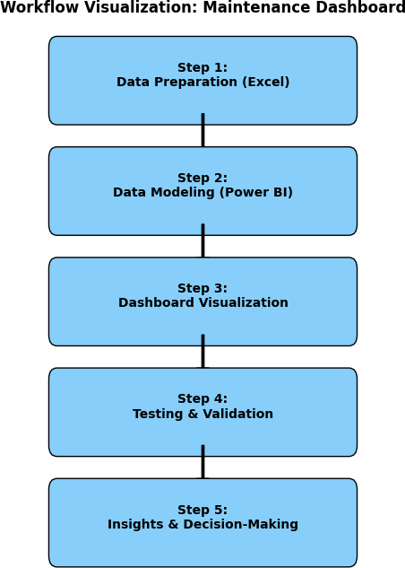

Fig. 2. Workflow Visualization of the Maintenance Dashboard showing sequential phases
- Results and Discussion
The Excel + Power BI Maintenance Dashboard that was created offers an interactive interface for tracking the effective- ness of maintenance and equipment performance. Data-driven decision-making is made possible by its integration of several KPIs, including MTTR, MTBF, repair costs, downtime, and event trends [32].
- Key Performance Indicators
  - MTTR (2.97 hours): Suggests effective repair proce- dures by indicating prompt response and failure resolu- tion.
  - MTBF (161 hrs): Reflects moderate reliability. Contin- uous improvement programs can be planned to further extend uptime.
  - Total Repair Costs (1M): Draws attention to the sizeable outlay for maintenance tasks and stresses the significance of cost reduction..
  - Average Cost per Event (2,xxx): Offers a standard by which to compare the cost-effectiveness of preventative versus corrective measures.
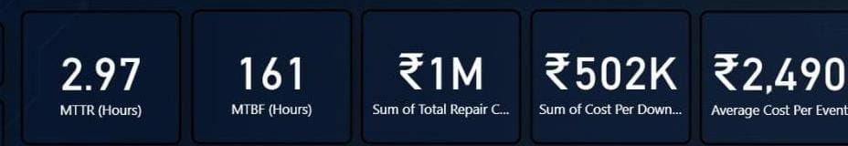
Fig. 3. Indicators

- Managerial Implications
- Predictive maintenance should replace reactive mainte- nance, which is indicated by a high level of unscheduled maintenance.
- Repair expenses for individual technicians show possible training requirements and skill gaps [33].
- Management can prioritise vital equipment for condition monitoring with the use of asset downtime insights.
- Cost-per-event analysis helps allocate funds and validates spending on predictive and automation technologies.
- Analysis of Dashboard Visuals
  - Repair Cost by Technician: Ritu Jain and Mohan were the most expensive technicians, indicating that cost-effective training or workload distribution may be possible (Refer Fig. 4).
  - Events Over Time: Preventive scheduling prior to peak periods can lessen this load; a June spike suggests seasonal or operational stress (Refer Fig. 5).
  - Downtime by Equipment: Conveyors and pumps con- tribute the most to downtime, which makes them priority assets for predictive maintenance (Refer Fig. 6).
  - Maintenance Type Distribution: Unscheduled main- tenance accounts for the majority (57.92%), indicating a clear need to move towards predictive and scheduled approaches in order to decrease unplanned malfunctions (Refer Fig. 7).

  - Average Cost per Event by Equipment: The highest cost per event is incurred by boilers, indicating the need for either stronger preventive controls or an asset replacement evaluation (Refer Fig. 8).
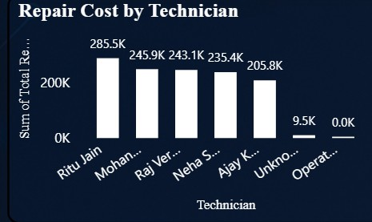
Fig. 4.

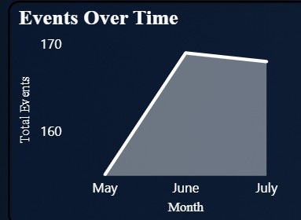

Fig. 5.

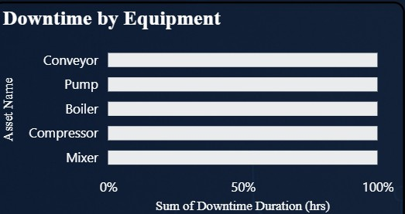

Fig. 6.

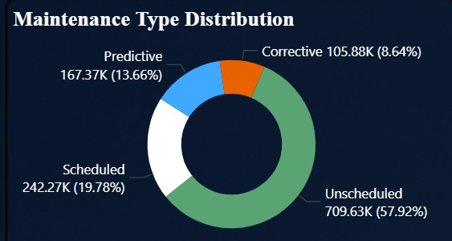

Fig. 7.
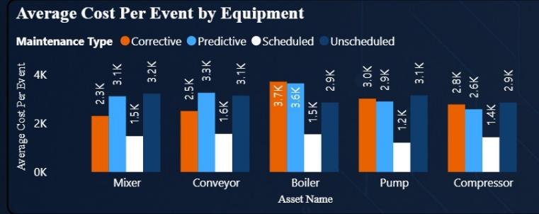

Fig. 8.

- Discussion

Shift from Reactive to Predictive Maintenance:
    - The current system is still primarily reactive, as evi- denced by the preponderance of unscheduled mainte- nance (57.92%).
    - Cost volatility and unscheduled downtime result from this. Through the use of predictive techniques(such as failure pattern analysis and sensor-based monitoring), malfunctions can be predicted and prevented [34].

Technician-Specific Performance Gaps:
    - High repair costs associated with specific technicians could be a sign of ineffective allocation or training.
    - Costs can be decreased by focused upskilling or improved task assignment if root-cause analysis reveals recurring mistakes or drawn-out repairs.

Critical Equipment Prioritization:
    - Conveyors and pumps account for the majority of down- time, which is consistent with their function as production bottleneck assets.
    - Using the principles of Total Productive Maintenance (TPM), such as Autonomous Maintenance and Focused Improvement can target these assets directly, guaranteeing increased availability.

Cost Management & Budget Allocation:
    - Boilers have the highest cost per event, which begs the question of whether the company should replace them or keep fixing them.
    - Decisions should be made using life cycle costing instead of just short-term repair costs.

Benchmarking & KPI Tracking:
    - The MTBF (161 hours) suggests potential for reliability improvement, while the MTTR (2.97 hours) is reason- able.
    - The organisation can test the effects of maintenance initiatives (e.g., scheduling changes, predictive systems) and benchmark improvements by monitoring KPIs on a monthly basis.

Strategic Insights for Managers:
    - Managers can use this dashboard for strategic planning as well as monitoring, including setting KPI-based goals, scheduling technician workloads, and optimising spare parts inventory [35].
    - The outcomes unequivocally demonstrate the operational and financial advantages of funding training initiatives and predictive maintenance.
- Challenges and Limitations
- Data Quality & Completeness
  - While the simulation’s data was structured for demonstra- tion, raw maintenance logs in actual industrial settings might have duplicate, inconsistent, or missing entries [36].
  - MTTR and MTBF are two examples of misleading KPIs that can result from incomplete failure records or erro- neous timestamps.
- Integration with Real-Time Systems
  - The current dashboard relies on static Excel data.
  - IoT sensors, CMMS (Computerised Maintenance Man- agement Systems), or ERP software are frequently the sources of maintenance data in a live setting.
  - In order to integrate Power BI with these real-time sources, sophisticated connectors, APIs, and occasionally extra licencing are needed.
- Scalability of Power BI
  - Very large datasets (such as millions of event logs from several plants) may experience performance lags, even though Power BI performs well with moderate datasets [37].
  - Costs may go up if optimisation methods like data modelling, incremental refresh, or Power BI Premium are used.
- Limited Predictive Capability
  - The dashboard’s current focus is on diagnostic and de- scriptive analytics (what happened, why it happened).
  - It is necessary to use sophisticated methods like machine learning, anomaly detection, and time-series forecasting for true predictive maintenance.
  - When it comes to predictive modelling, Power BI by itself offers little assistance unless it is integrated with other tools (such as Python/R or Azure ML).
- User Adoption & Training
  - Even if the dashboard offers insightful information, its usefulness hinges on how well technicians and mainte- nance managers can understand and act upon it.
  - The impact in the real world could be limited by resis- tance to change or a lack of data literacy.
- Conclusion
This paper effectively illustrated how to use Excel and Power BI to design and develop a maintenance dashboard that visualises and analyses data related to maintenance. The dash- board provided useful insights into equipment performance by efficiently tracking key performance indicators like Mean Time to Repair (MTTR), Mean Time Between Failures (MTBF), downtime, event trends, and repair costs [38].
The combination of Power BI for modelling and visualisa- tion and Excel for data preparation demonstrates how easily accessible tools can be combined to produce a potent decision- support system. The dashboard demonstrated how companies can monitor asset health, optimise resource allocation, and enhance decision-making in accordance with Total Productive Maintenance (TPM) principles by simulating scheduled and unscheduled maintenance activities.
However, some drawbacks were noted, including the dash- board’s dependence on static data, scalability problems, and limited predictive power. These suggest that although the dashboard works well for monitoring and demonstration, more improvements are needed for industrial-scale implementation.
- Future Work
This project can be improved in a number of ways to increase its usefulness and practicality:

AI Machine Learning Integration
  - To anticipate equipment failures before they happen, use machine learning-based predictive maintenance models [39].
  - For early warnings, employ methods such as anomaly detection, classification models, and time- series forecasting.

IoT & Real-Time Data Streaming
  - To facilitate real-time data collection and live mon- itoring, connect the dashboard to CMMS systems and Internet of Things sensors.
  - For constant updates, use cloud platforms (AWS, Azure) or Power BI streaming datasets.

Cloud-Based Deployment
  - For scalability, improved teamwork, and remote access across several plants or locations, deploy the dashboard in the cloud [40].
  - For comprehensive asset management, this also makes integration with ERP systems possible.

Advanced Analytics Automation
  - Include automated alerts and notifications as well as what-if scenario analysis when KPI thresholds are breached.

  - Work orders can be automatically generated by con- necting the dashboard to maintenance scheduling systems.
References
- REWO Analytics, ”The True Cost of Downtime from Human Error in Manufacturing,” Manufacturing Operations Research, vol. 8, no. 2, pp. 112-128, Feb. 2025.
- M. Workneh and A. P. Singh, ”Total Productive Maintenance: A Case Study in Manufacturing Industry,” Global Journal of Researches in Engineering, vol. 12, no. 4, pp. 23-35, 2012.
- A. Benhanifia, Z. B. Cheikh, P. M. Oliveira, A. Valente, and J. L. S. de Magalha˜es, “Systematic review of predictive maintenance practices in the manufacturing sector,” *Intelligent Systems with Applications*, vol. 26, art. 200501, Apr. 2025.
- Siemens Digital Industries, ”Maximising ROI with Scalable Predictive Maintenance: Industrial Transformation Report 2023,” Siemens AG Technical Paper, 2023.
- B. Dal, P. Tugwell, and R. Greatbanks, “Overall equipment effectiveness as a measure of operational improvement–a practical analysis,” Int. J. Operat. Prod. Manage., vol. 20, no. 12, pp. 1488–1502, Dec. 2000.
- Emilio Ferrara. 2015. Manipulation and abuse on social media by emilio ferrara with ching-man au yeung as coordinator. ACM SIGWEB Newsletter Spring (2015), 4.
- R. Raj, S. H. S. Wong, and A. J. Beaumont, “Empowering SMEs to make better decisions with Business Intelligence: a case study,” in *Knowledge Discovery, Knowledge Engineering and Knowledge Management*, A. Fred, J. Dietz, D. Aveiro, K. Liu, J. Bernardino, and J. Filipe, Eds., Communications in Computer and Information Science, vol. 914. Cham, Switzerland: Springer, 2018, pp. 306–325.
- A. Manufacturing Excellence Institute, ”Implementation of Overall Equipment Effectiveness (OEE) in Maintenance Management: A Com- prehensive Review,” IEOM Society International Conference Proceed- ings, Harare, Zimbabwe, pp. 3085-3095, Dec. 2020.
- N. Kamaruddin, R. D. Safiyah, and A. Wahab, “Small and medium enterprise business solutions using data visualization,” *Bull. Electr. Eng. Informatics*, vol. 9, no. 6, pp. 2562–2568, Dec. 2020.
- S. Nakajima, Introduction to TPM: Total Productive Maintenance, Cambridge, MA: Productivity Press, 1988.
- I. P. S. Ahuja and J. S. Khamba, ”An evaluation of TPM initiatives in Indian industry for enhanced manufacturing performance,” International Journal of Quality & Reliability Management, vol. 25, no. 2, pp. 147- 172, 2008.
- A. K. S. Jardine, D. Lin, and D. Banjevic, ”A review on machinery di- agnostics and prognostics implementing condition-based maintenance,” Mechanical Systems and Signal Processing, vol. 20, no. 7, pp. 1483- 1510, Sept. 2006.
- J. Lee, B. Bagheri, and H.-A. Kao, ”A cyber-physical systems archi- tecture for Industry 4.0-based manufacturing systems,” Manufacturing Letters, vol. 3, pp. 18-23, Jan. 2015.
- R. K. Mobley, An Introduction to Predictive Maintenance, 2nd ed. Amsterdam: Butterworth-Heinemann, 2002.
- G. Waeyenbergh and L. Pintelon, ”A framework for maintenance con- cept development,” International Journal of Production Economics, vol. 77, no. 3, pp. 299-313, June 2002.
- P. Muchiri and L. Pintelon, ”Performance measurement using overall equipment effectiveness (OEE): literature review and practical applica- tion discussion,” International Journal of Production Research, vol. 46, no. 13, pp. 3517-3535, July 2008.
- M. C. Eti, S. O. T. Ogaji, and S. D. Probert, ”Strategic maintenance- management in Nigerian industries,” Applied Energy, vol. 83, no. 3, pp. 211-227, Mar. 2006.
- B. H. Wixom and H. J. Watson, ”An empirical investigation of the factors affecting data warehousing success,” MIS Quarterly, vol. 25, no. 1, pp. 17-41, Mar. 2001.
- A. Ayad and U. Dippel, “Agent-based monitoring of virtual machines,” in *Proc. Int. Symp. Inf. Technol. (ITSIM)*, Kuala Lumpur, Malaysia, Jun. 2010, pp. 1–6.
- F. Nunes, E. Alexandre, and P. D. Gaspar, “Implementing Key Perfor- mance Indicators and Designing Dashboard Solutions in an Automotive Components Company: A Case Study,” *Administrative Sciences*, vol. 14, no. 8, art. 175, Aug. 2024.
- K. K. Tirupati, A. Joshi, S. P. Singh, A. Chhapola, S. Jain, and A. Gupta, “Leveraging Power BI for enhanced data visualization and business intelligence,” *Universal Research Reports*, vol. 10, no. 2, pp. 676–711, Jun. 2023.
- F. T. S. Chan, H. C. W. Lau, R. W. L. Ip, H. K. Chan, and S. Kong,
“Implementation of total productive maintenance: A case study,” *Int.
J. Prod. Econ.*, vol. 95, no. 1, pp. 71–94, Jan. 2005.
- M. S. Gounder, V. V. Iyer, and A. A. Al-Mazyad, “A survey on business intelligence tools for university dashboard development,” in *Proc. 3rd MEC Int. Conf. Big Data Smart City (ICBDSC)*, Feb. 2016, pp. 1–7.
- A. Bousdekis, B. Magoutas, D. Apostolou, and G. Mentzas, ”A proactive decision making framework for condition-based maintenance,” Industrial Management & Data Systems, vol. 115, no. 7, pp. 1225-1250, Aug. 2015.
- T. Ylipa¨a¨, J. Skoogh, J. E. Bokrantz, and A. Gopalakrishnan, ”Identi- fication of maintenance improvement potential using OEE assessment,” International Journal of Productivity and Performance Management, vol. 66, no. 1, pp. 126-143, Feb. 2017.
- A. Teguede Keleko, B. Kamsu-Foguem, R. Houe Ngouna, and A. Tongne, “Artificial intelligence and real-time predictive maintenance in Industry 4.0: a bibliometric analysis,” *AI and Ethics*, vol. 2, pp. 553–577, Mar. 2022.
- X. Pang, Y. Zhou, P. Wang, W. Lin, and V. Chang, “An innovative neural network approach for stock market prediction,” *J. Supercomputing*, vol. 76, pp. 2098–2118, Jan. 2020.
- Z. Yeze and Y. Yiying, “Stock price prediction based on information en- tropy and artificial neural network,” in *Proc. 5th Int. Conf. Information Manage. (ICIM)*, Cambridge, U.K., Mar. 2019, pp. 248–251.
- V. Pravallika and M. Anuradha, “Hybrid deep learning for breast cancer detection: CNN-RNN approach vs traditional machine learning models,”
*Int. J. Multidisciplin. Res. Growth Eval.*, vol. 6, no. 3, pp. 853–858, May–Jun. 2025.
- Z Lin, Y Chen, X Zhao, G Wang, in Proc. 9th Int. Conf. Inf., Commun. Signal Process. (ICICS). Spectral-spatial classification of hyperspectral image using autoencoders, (Dec. 2013), pp. 1–5.
- K. Mamatha and A. K. Sudheer, “Evaluating the role of E-HRM in enhancing employee engagement and organizational commitment in remote work environments,” unpublished manuscript, ResearchGate, May 2025.
- F. Nunes, E. Alexandre, and P. D. Gaspar, “Implementing Key Perfor- mance Indicators and Designing Dashboard Solutions in an Automotive Components Company: A Case Study,” *Adm. Sci.*, vol. 14, no. 8, art. 175, Aug. 2024.
- R. Tirupathi, B. Bogi, V. Marella, S. Gudavalli, and P. Goel, “A hybrid machine learning framework for predictive maintenance in smart manufacturing,” presented at the Int. Conf. Innovative Comput. Technol., Hyderabad, India, Dec. 2024.
- K. Daniewski, E. Kosicka, and D. Mazurkiewicz, “Analysis of the correctness of determination of the effectiveness of maintenance service actions,” *Manuf. Prod. Eng. Rev.*, vol. 9, no. 2, pp. 20–25, June 2018.
- S. Almasi, K. Bahaadinbeigy, H. Ahmadi, S. Sohrabei, and R. Rabiei, “Usability evaluation of dashboards: A systematic literature review of tools,” *Biomed. Res. Int.*, vol. 2023, Art. ID 9990933, 11 pages, Feb. 2023.
- T. Nkosi and F. Emuze, “Predictive maintenance and data analytics: current insights,” in *Proc. IEEE Int. Conf. Industrial Engineering and Engineering Management (IEEM)*, Bangkok, Thailand, Dec. 2024, pp. 1–6.
- T. Flick, “Cost-benefit analysis of various dashboard scaling strategies,” unpublished manuscript, ResearchGate, May 2025.
- J. Kobi, “Developing dashboard analytics and visualization tools for ef- fective performance management and continuous process improvement,”
*Int. J. Innov. Sci. Res. Technol.* (IJISRT), vol. 9, no. 5, pp. 1697–1709, May 2024.
- C. Okoh, R. Roy, and J. Mehnen, “Maintenance informatics dashboard design for through-life engineering services,” in *Proc. 5th Int. Conf. Through-Life Engineering Services (TESConf 2016)*, Procedia CIRP, vol. 59, pp. 166–171, 2017.
- T. Soetan, “The future of AI-powered Business Intelligence dashboards: emerging trends and technologies,” unpublished manuscript, uploaded Apr. 2025.

